**Log-in Page:** for program to see who user is to know which page to display and to secure information

**Teacher/Administrator Page:** for teacher to be able to add and edit contacts/guides and add and edit rooms and their descriptions.

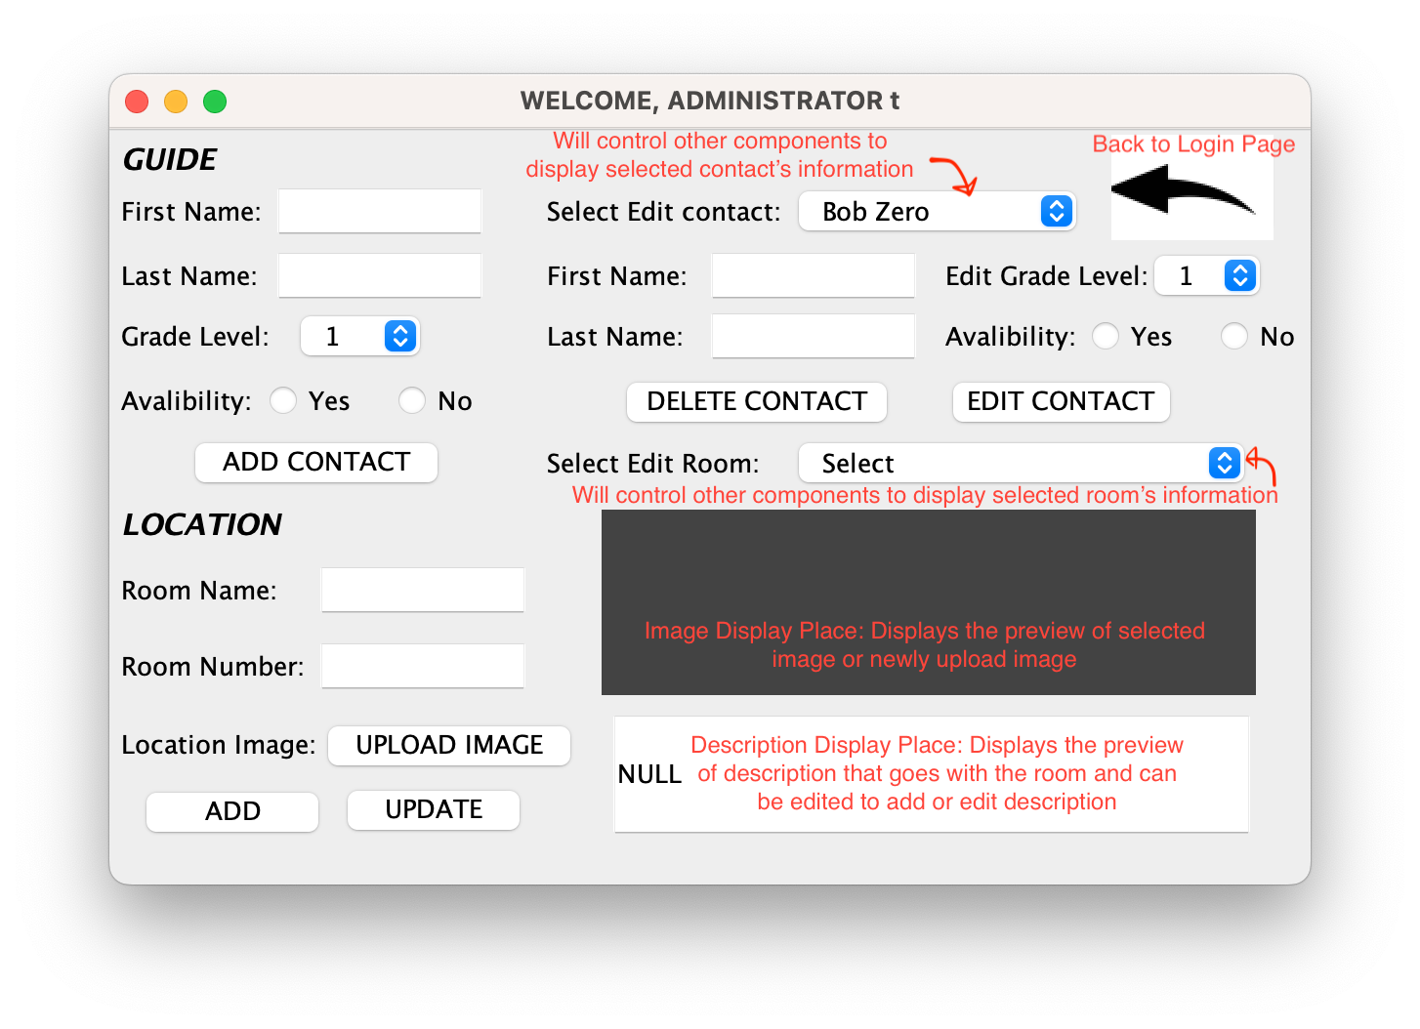

**Student Page:** for students to see instructions on how to get from one place to another with step by step locations that could be switched back and forth with the next button. Can also see contacts/guides

**List of some Classes and Algorithms, Data Structures, Methods possibly used:**

Images: Upload and edit Images

Files: Upload and edit Files

GUIs and Javax: Building the GUIs

ActionListener: used so then can set what happens after a GUI component is clicked or such

Array: elements will be stored in these as its easier to handle around and take out

HashMap: use to store the passwords and id

Bubble Sort: sort the contacts and also the rooms after shifting and deleting and editing

Abstraction, get and set methods, hiding private code for security reasons

Encapsulation

Switching between data structures (Primitive data type or not, etc.)

|  |  |  |  |  |  |  |  |  |  |  |  |  |  |
| --- | --- | --- | --- | --- | --- | --- | --- | --- | --- | --- | --- | --- | --- |
| |  | | --- | | CONTACTS | | Number: to know what index elements of the class are located at | | Contacts: the full name of the contact, to be displayed on the choices lists | | FirstName: first name of the contact | | LastName: last name of the contact | | Grades: the grade level of the student | | Availability: whether or not the student is avalible for guiding or help if needed | | |  | | --- | | ROOMS | | Roomname: the name of the room | | Roomnumber: the number of the room | | Roomdescription: the description/route instructions to go the next room | | Roomimage: the image of the room itself to be displayed | |

**General File Structures: (How I will Organize My Code/Classes)**

**Knowledge for some Parameters Based on Consultations:**

* Maximum of 20 contacts (only that many people allowed in the club)
* Location is the school so also not that big of routes
* Routes can go in order of the rooms set by administrator
* Username and Password set to “s” and “s” for students and “t” and “t” for teachers
* No need to change password and username for now

**Test Plan:**

|  |  |  |
| --- | --- | --- |
| **Action Test** | **Method of Testing & Results** | **Example (Some Main Examples)** |
| Check to see the functionality of the log in page, reset button, submit button | Typing random texts into username and password and resetting them. click submit with correct and incorrect passwords | Username s, Password s  Takes to Student Page  Username t, Passwords t  Takes to Teacher Page |
| Check to see if the default functionality of all graphical components work | Check if default selection shows correct image and if all graphical interface component shows up. All editable components should be editable and all non-editable components should not be edible | Image/icons should show default image/icons  Lists should contain correct items and be on default selection item |
| Check to see if can add contact function work. | Check reaction of interface after clicking certain button or items from lists and typing on text fields. | Add contact should refresh items listed in the comboBox in the edit contact section. |
| Check to see the functionality of editing contacts | Check to see if text fields displays correct text after selecting contact to edit and checking to see if can change contact information after clicking update or delete contact button | Text fields should display previously stored information after a contact is selected from the edit contact list. Delete, Update, Add Buttons should work. |
| Check to see if can add and edit rooms | Check to see if can upload image properly and if can type text in different fields. See if image gets displayed on the right side | Selecting a room to edit will display it’s room’s image, room numbers, name, on correct fields, etc. |
| Check to see if back Button works | Should be able to return to the log in page on both the student and teacher page | Back to log in page after clicking |
| Check to see if contact can be sorted by Contact | see if contacts are sorted by availability | Contacts that are available on the top of pane and contacts that are not on the bottom, sorted by grade level (from biggest to smallest) |
| Check to see if can set room location to go to different rooms and if Go button Functions properly | Clicking go button would send information to load certain set of image and description for students to see. Should be able to click the next button to see next room to go to reach final location | Room 1 to Room 4:  Displays Image and route instruction to to next room 🡪 Clicks next 🡪 Displays second Image (Room 2) and seconds route instructions🡪Repeat steps |